Group 9 - BookKeeper

User Stories

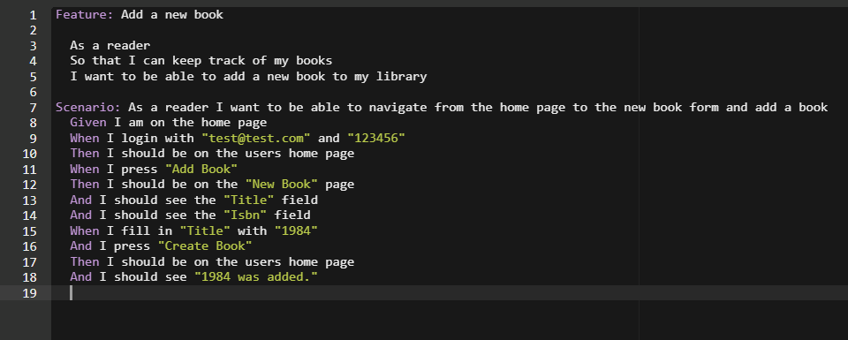

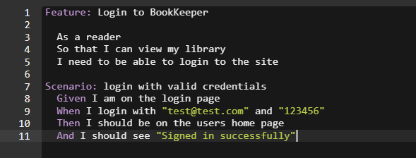

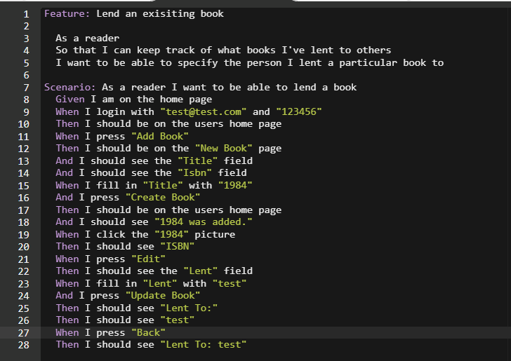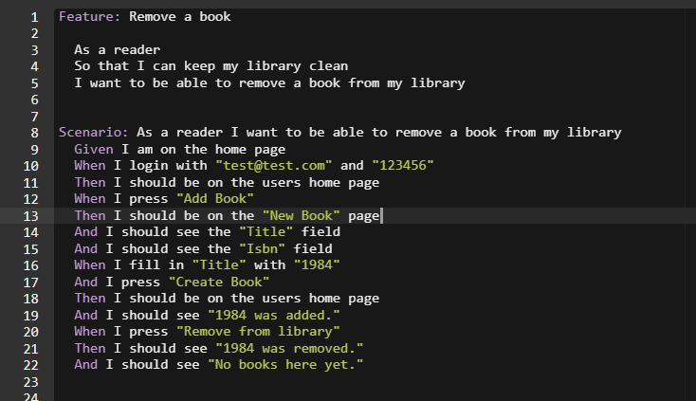

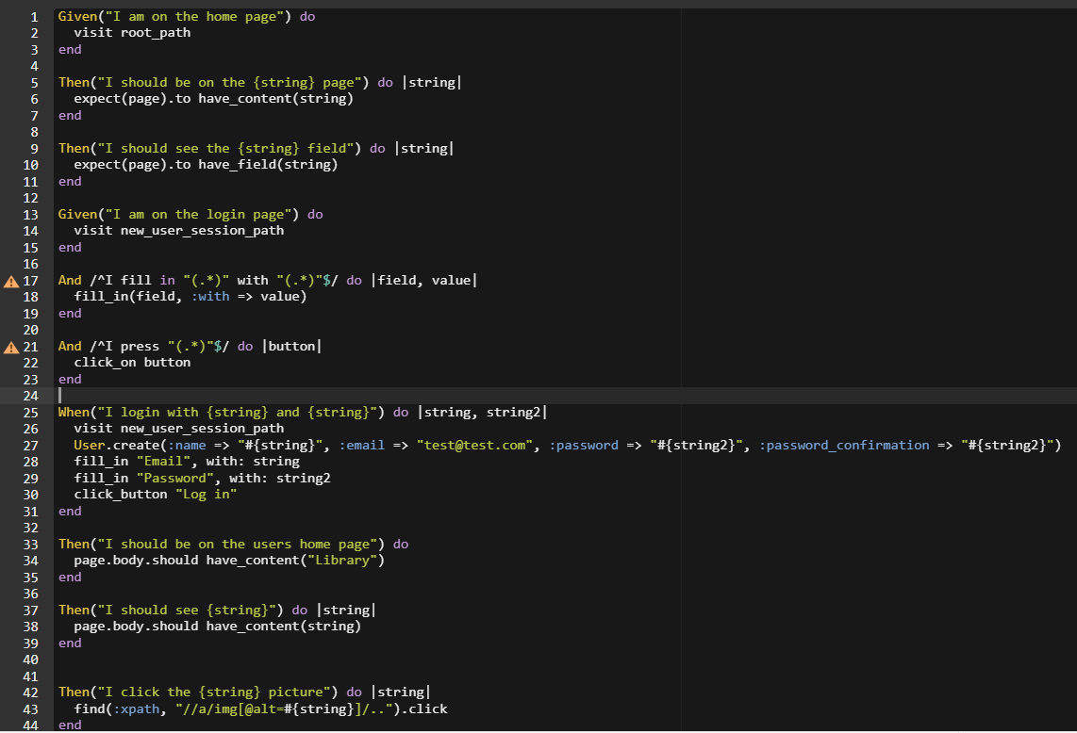

All user stories and testing were done in Cucumber and Capybara.

Login:

* Tests that a user should be able to login, given that their credentials are already in the system. The database is populated with a new user using the credentials “[test@test.com](mailto:test@test.com)” and password “123456”. Then the test checks that the user is on the homepage and sees the correct sign-in message.

Add Book:

* Tests that a user should be able to add a book after signing in. It simulates the action of the user clicking on the add book button and filling in details for “1984”. Then, it checks that the book was successfully created, and that the user is sent to the right place afterwards.

Lend Book:

* This test makes sure that the user can edit the book, especially in regards to lending the book out to somebody. It simulates the user signing in, creating a book, and then editing the book to add the name of who they lent it to. Afterwards, it checks that the user is sent to the correct page, and that the note saying who the book was lent to is present.

Remove Book:

* This test ensures that the user is able to remove a book from their library after adding it. The test simulates the user logging in, adding a book, then removing the book. It checks for the correct messages that the application displays upon completion of these actions.

Passing Scenarios:

